DISSERTATION
Examine whether entrepreneurship can be considered a realistic route into work for unemployed Jordanians aged 18 to 35

Deceleration
It is my own academic work, which is completed according to the requirements of my programme, and I declare it. The study has been carried out in a good manner and with a sense of responsibility, and the data provided has been utilised to the aim of this study. I establish that the primary data prepared and utilised in this study was retrieved from qualified respondents, and the results obtained were analysed and reported as per the research methodology. I have taken into consideration typical sources of information used during the research and have not foolishly presented the work of another person as my own. I realise that plagiarising or submitting work that does not meet the academic requirements and rules of the university can be considered academic misconduct. I thus take responsibility for the originality, truth and faithfulness of the work presented.

Table of Contents
Chapter 1: Introduction 8
1.1 Background 8
1.2 Problem Statement 8
1.3 Rationale 8
1.4 Aim and Objectives 9
1.5 Research Questions 9
1.6 Significance 9
1.7 Scope 9
1.8 Brief Summary of Methodology 10
1.9 Dissertation structure 10
Chapter 2: Literature review 11
2.1 Introduction 11
2.2 Conceptual framework 11
2.3 Theoretical framework 12
2.4 Attitudes towards Entrepreneurship as an Employment Pathway 13
2.5 Perceived Barriers to Starting a Business 14
2.6 Perceived Support and Entrepreneurial Intention 15
2.7 Policy, University and Institutional Support 17
2.8 Research Gap 18
2.9 Conclusion 19
Chapter 3: Research Methodology 20
3.1 Introduction 20
3.2 Research Philosophy 20
3.3 Research Approach 20
3.4 Research Design 21
3.5 Population and Sampling 21
3.6 Eligibility and Screening 22
3.7 Data Collection Method 22
3.8 Pilot Study 23
3.9 Data Analysis 23
3.10 Ethical Considerations 24
3.11 Chapter Summary 24
Chapter 4: Findings and Discussion 25
4.1 Chapter introduction 25
4.2 Findings 25
4.3 Analysis 45
4.4 Discussion 48
4.5 Chapter summary 52
Chapter 5: Conclusion 53
5.1 Conclusion 53
5.2 Recommendations 53
5.3 Summary of research contribution and its alignment with research objectives 54
5.4 Limitations and future directions 54
5.5 Personal reflection and development 55
References 56
Appendix 62
Questionnaire 62

List of figures
Figure 1: Conceptual framework 12
Figure 2: Frequency Statistics of Q1–Q12 25
Figure 3: Frequency Statistics of Q13–Q20 26
Figure 4: Frequency Tables for Q1–Q3 27
Figure 5: Frequency Tables for Q4–Q6 28
Figure 6: Frequency Tables for Q7–Q9 29
Figure 7: Frequency Tables for Q10–Q12 30
Figure 8: Frequency Tables for Q13-15 31
Figure 9: Frequency Tables for Q16-Q18 32
Figure 10: Frequency Tables for Q19-Q20 33
Figure 11: Descriptive Statistics Q1-Q9 34
Figure 12: Descriptive Statistics Q10-Q19 35
Figure 13: Reliability Analysis1-4 question 36
Figure 14: Reliability Analysis 5-10 question 37
Figure 15: Reliability Analysis11-15 question 38
Figure 16: Reliability Analysis16-19 question 39
Figure 17: Pearson Correlation Results for Q1–Q11 40
Figure 18: Pearson Correlation Results for Q12–Q19 41
Figure 19: Pearson Correlation Results for Q9–Q17 42
Figure 20: Pearson Correlation Results for Q9–Q17 42
Figure 21: Pearson Correlation Results for Q18–Q19 43
Figure 22: Pearson Correlation Results for Q18–Q19 43
Figure 23: Multiple Linear Regression Results for Intention 44

Acknowledgment
I would also like to say that I would like to thank those who helped me during the course of this research project. I would especially like to admit that my supervisor helped me greatly with her guidance, positive feedback and support at various points of the research. I would like to give my thanks to all the participants who took the time to fill in the questionnaire and submit the information necessary to undertake this project. Their involvement ensured that they were able to gather the primary data that would enable answering the research objectives. I am also grateful to my university for providing the academic resources and learning environment necessary to accomplish this research.

Executive Summary
This paper has explored the possibility of considering entrepreneurship as a viable path to employment among unemployed Jordanians between the ages of 18 and 35. The study targeted young adults who faced unemployment and considered their attitudes towards entrepreneurship, the perceived obstacles involved when thinking of starting a business, the available support for them and their intention to start a business. The present research methodology mainly consists of a quantitative study, and the primary data were collected through a structured questionnaire on the Internet. Also, the questionnaire targeted behaviour in terms of entrepreneurship, barriers, perceived sustenance, and entrepreneurial intention. The data obtained were analysed with descriptive statistics, reliability analysis, multiple regression and Pearson correlation. The results indicated that the respondents were basically positive towards entrepreneurship as a form of employment. A significant percentage of them considered starting a business to be an appropriate career choice and had a rather high entrepreneurial intention level.
Nonetheless, economic troubles were a significant issue. Personal finance insufficiency and challenges in availing external finance were some of the main barriers identified by the respondents. Other issues were business knowledge, skills, networks and administrative needs. The results also revealed that the perceived support was positively linked to entrepreneurial intention. Information, mentoring, training, financial support and organisational support were thus seen as key support to the young people exploring the field of entrepreneurship. The results of the regression analysis were that attitudes, perceived support and perceived barriers were all significantly correlated with entrepreneurial intention and collectively explained 70.2% of the variation in entrepreneurial intention. In general, the research findings established that entrepreneurship may offer a viable job opportunity to unemployed young Jordanians, yet it was reliant on the availability of appropriate financial, educational, practical and institutional support. The research findings thus suggested better start-up finance, realistic entrepreneurship education, mentoring, networking and better access to youth entrepreneurship programmes.

Chapter 1: Introduction

1.1 Background
Unemployment among young people is a significant social and economic problem in Jordan, especially among young adults who are trying to access the labour market. Young people have limited access to job opportunities, face challenges in the transition between school and employment, and employment pressures in global labour markets can limit young people's ability to gain financial autonomy and develop stable careers. In that regard, entrepreneurship is becoming a viable option for entry into the labour market since initiating a business venture could enable people without jobs to generate their own jobs, as well as perhaps broadening overall economic activity (Ratten 2023).

1.2 Problem Statement
Despite the target of entrepreneurship as a potential remedy to youth unemployment, there is a disparity between promoting entrepreneurship and empowering unemployed youth to set up sustainable businesses. The economic constraints, lack of business education, lack of practical experience, societal pressures, legal conditioning and unavailability of mentorship can affect an individual's willingness to contemplate self-employment. Unemployed young adults can thus identify the possible opportunities of being an entrepreneur, and at the same time business creation seems to be excessively risky or challenging (Botelho, Fehder, and Hochberg 2026).

1.3 Rationale
The research is motivated by the fact that the issue of youth employment remains significant and requires some insights into the possibility of entrepreneurship being an effective alternative method of employment. Determining the attitudes of unemployed adults towards entrepreneurship can assist in separating a combination of general interest in trying an entrepreneurial activity and an actual desire to become one. Knowing the barriers that this group encounters or expects to encounter can also help to point out where support can be lacking. Moreover, reviewing the contribution of the finance, training, mentoring and youth employment programmes might give a better insight into the circumstances that can prompt entrepreneurial intention (Huang et al. 2023).

1.4 Aim and Objectives
- Aim: The main aim of this study is to examine whether entrepreneurship can be considered a realistic route into work for unemployed Jordanians aged 18 to 35.
The objectives are:
- To measure unemployed young adults’ attitudes towards entrepreneurship as an employment pathway in Jordan.
- To identify perceived barriers to starting a business, including financial, educational, social, institutional, and practical barriers.
- To examine whether perceived support, such as finance, training, mentoring and youth employment programmes, is associated with stronger entrepreneurial intention.
- To collect primary survey data from unemployed Jordanians aged 18 to 35.
- To provide recommendations for policymakers, universities, and support organisations.

1.5 Research Questions
- How do attitudes, perceived barriers and perceived support influence entrepreneurial intention among unemployed Jordanians aged 18 to 35?

1.6 Significance
The research has its importance as it features the protagonist of the research work as young adults who lack jobs, and thus they explain the issues of entrepreneurship and youth unemployment. Its results can be used to understand more about what motivates or puts off the thought of an entrepreneurial career as a job. The knowledge of young unemployed individuals on whether they need more practical preparation to be able to engage in entrepreneurial activity might be beneficial to universities (Audretsch and Fiedler, 2023).

1.7 Scope
The population under study is the unemployed Jordanian nationals between 18 and 35 years old who reside in Jordan. The study takes into account the attitudes towards entrepreneurship, entrepreneurial intention, perceived barriers and perceived support. It does not investigate those who already have businesses, those who are employed, children or anyone who is not within the given age bracket (Guo, Cheng, and Wang, 2024).

1.8 Brief Summary of Methodology
The type of research that will be used is a quantitative, deductive and cross-sectional research design. When the data are collected, primary data will be used with the help of an online questionnaire (unemployed Jordanians aged between 18 and 35). Online methods will be used to recruit the participants using snowball sampling, based on purposive and voluntary snowball methods of accessing respondents who will be eligible. It will identify roughly 150 participants, of which we hope to have at least 100 who will be useful. The questionnaire shall be a closed-ended questionnaire provided in terms of the five-point Likert scale that will focus on attitudes, entrepreneurial intention, perceived barriers, and perceived support. Descriptive statistics, Cronbach's alpha, Pearson correlation and multiple regression will be used to analyse data using SPSS. The correlation will be carried out on the study variables without drawing causal statements.

1.9 Dissertation structure
Chapter one focuses on evaluating the background of the study in the context of the aim and, accordingly, states the key problem that this research study will address. Another chapter is the literature review, which emphasises evaluating key understanding in terms of youth unemployment and entrepreneurship. Chapter three focuses on discussing different methods that have been taken into account for the collection of information. Chapter four, which presents the findings and discussion, emphasises evaluating key results, and chapter five focuses on conclusions and recommendations.

Chapter 2: Literature review

2.1 Introduction
Youth unemployment is one of the old socio-economic issues in Jordan that triggers the expected shift to entrepreneurship as one of the possible employment opportunities (Alshraiedeh, 2024). This literature review will critically analyse theoretical approaches, as well as empirical observations concerning entrepreneurial attitudes, barriers, institutional support, policy interventions and the gap in the research that is the basis of the current study. Therefore, the research treats entrepreneurship both as a possible way of employment and as a choice based on personal perceptions and the environment. A keen focus is given to attitudes, financial situations, knowledge and skills, social support, access levels to information, mentoring and institutional support on the influence of entrepreneurial intention.

2.2 Conceptual framework
The conceptual framework that shall be applied in this research will involve viewing the attitudes of the entrepreneur to the entrepreneurial financial resources and barriers, as well as education, entrepreneurship skills, family and social support, access to business information and mentoring as the independent variables. These variables are recognised in the literature reviewed in this study as critical individual and contextual variables that could be influential in the case of young people's perceptions of entrepreneurship and their intentions to be entrepreneurs. The dependent variable is entrepreneurial intention because the research question is whether the variation of such perceptions and external factors affects the desire of the respondents to take the option of entrepreneurship in the form of a job (Alharbi, 2020).
It is expected that increased entrepreneurial intention will be linked with increased positive attitudes towards entrepreneurship, increased financing, stronger entrepreneurial knowledge and skills, increased family and social support, increased access to business information and mentorship, and stronger institutional support. On the other hand, lower levels of entrepreneurial intention can be connected to financial limitations and other perceived obstacles (Jannesari, 2022).
The framework also allows the study to make comparisons between responses in the identified variables. As an illustration, the respondents describing stronger access to financial resources may be compared to those with the description of lesser access to financial resources in terms of the intention to become an entrepreneur. Likewise, the same could be said of education, practical skills, family support, business information, mentoring and institutional support, with reference to the intent of respondents to become an entrepreneur.
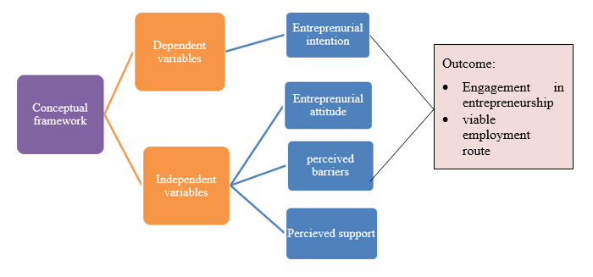
Figure 1: Conceptual framework

2.3 Theoretical framework
The questionnaire more specifically has the Theory of Planned Behaviour as its basis, with its three major components reflected by using questions about individual perceptions. The questionnaire provides Likert scale statements to quantify the attitudes towards entrepreneurship, subjective norms and perceived behavioural control, and entrepreneurial intention is determined by the willingness and intentions of the respondents to become an entrepreneur. The questions were designed keeping in mind the pre-existing strategies of measuring these constructs, but modified to reflect the scenario of unemployed youth in Jordan.
The Human Capital Theory will provide a basis to explore the question of whether the use of knowledge, practical skills, education and training has anything to do with the intention to be an entrepreneur. Education might not in any way mean that someone is ready to start up a business, as either practical knowledge, skills and confidence would as well work on perceived readiness to become an entrepreneur.
Education, business knowledge and practical skills can add to a person's capability to see opportunity and know what needs to be done to start a business. Being entrepreneur-prepared is not achieved only through formal education, and people may vary in terms of practical experience, training and confidence. The higher the perceived capabilities, the more they can counter some of the perceived barriers to starting a business, and the lower the level of knowledge or competencies, the more they can reinforce the perceptions of entrepreneurial difficulties.

2.4 Attitudes towards Entrepreneurship as an Employment Pathway
Entrepreneurial pursuits have also been included as an alternative form of employment by youth who are finding it hard to secure labour market jobs. Tian et al., (2022) stated that positive attitudes towards entrepreneurship are a strong indicator of entrepreneurial intention since a person has higher probabilities of trying to start a business in cases where the attitude towards entrepreneurship is positive and attainable. In line with this argument, Guo et al., (2022) emphasised that positive entrepreneurial attitudes are a significant predictor of intentions to start a new venture, and this showed that psychological factors are significant in entrepreneurial decision-making.
However, this relationship is controversial in developing economies. According to Alkhozahe, (2025), despite emerging favourable attitudes among unemployed young Jordanians towards entrepreneurship, their intentions hardly result in the creation of businesses since labour market insecurity and economic uncertainty diminish confidence in the success of the business. Likewise, Maheshwari, Kha and Arokiasamy, (2023) argued that chronic unemployment among youth is an indicator of structural weaknesses in the economy, and not a lack of entrepreneurial interest. These results indicate that entrepreneurial attitudes per se cannot be considered to be a complete and full picture of entrepreneurial behaviour.
Ogu, (2025), on the other hand, notes that entrepreneurship is a successful tool in enhancing the employment of youth in society through promoting innovation, self-employment and even economic diversification. Rodrik and Stiglitz, (2025) argue against this optimistic viewpoint in that entrepreneurship should be an addition to formal employment, not a substitution, since new businesses are very prone to failure without the necessary institutional support. Such contradictory results point to the fact that entrepreneurship cannot be referred to as a one-size-fits-all solution to unemployment among young people.
The attitudes towards entrepreneurship also do matter since they may contribute to the appearance of an intention to become an entrepreneur. An individual might identify entrepreneurship as a potentially good career option without even planning to start a business (Kovaleva et al., 2023). Thus, a positive attitude should be different to the entrepreneurial intention since intention is a more willing or intending behaviour to engage in entrepreneurial activity. According to the Theory of Planned Behaviour, attitudes that lean towards a specific behaviour may lead to greater intentions to engage in the behaviour provided that the individuals also believe that the behaviour is not only in their power but also acceptable in society. Where the entrepreneurs are young people looking to secure a job, entrepreneurship can thus be regarded as a positive thing, though the choice to venture into it is contingent on perceived financial, social and institutional circumstances.

2.5 Perceived Barriers to Starting a Business
As much as the idea of entrepreneurship is being marketed as one of the solutions to the problem of unemployment among the youth, the literature shows that young people faced with the issue of unemployment do experience a lot of barriers that make their chances of setting up a business less likely. One of the most outstanding factors always cited as a constraint is financial barriers. According to Belhaj Fraj et al. (2022), they argue that a lack of financing, high collateral and risk-averse banking systems deter young entrepreneurs when they start businesses in Jordan. On the same note, Bozward et al., (2022) added that lack of accessibility to start-up capital limits entrepreneurial activity in most developing economies. Nevertheless, money alone does not bring success into entrepreneurship since poor business planning and management skills often result in business failure.
There is also an emphasis on educational barriers in the literature. According to Auerbach and Green (2025), Human Capital Theory implies that education and entrepreneurial skills would improve the capabilities of persons to find opportunities and to conduct businesses efficiently. In agreement with this argument, entrepreneurship education has a positive impact on entrepreneurial knowledge and business confidence. Conversely, Edeji (2024) claim that a great number of university programs are very theoretical and do not equip students with any practical entrepreneurial skills, which restricts their preparation to be self-employed. This comparison shows that education quality might be superior to education attainment only.
Entrepreneurial decisions are further influenced by social and cultural barriers. According to Kromidha et al., (2022), challenging family demands, the fear of losing a business and the cultural wish to have a grade job in a government office are all factors that put off entrepreneurship among young people in Jordan. Similarly, as mentioned by Obschonka, Moeller and Goethner, (2022), social norms and gender expectations are other limitations, especially in the case of young women pursuing entrepreneurial jobs. On the other hand, the shift in cultural attitudes as well as increasing digital opportunities are slowly shifting the perception of entrepreneurship among the younger generations, albeit unevenly spread across regions.
The perception of barriers can also have an impact on entrepreneurial intention because it can lead to people holding the view that business creation can and should be real. The financial constraints may give the idea of starting a business seem risky, and the lack of knowledge, skills, or experience can lead to low confidence in being able to start and operate a business (Kovaleva et al., 2023). Entrepreneurship may be discouraged as well by social expectations in which traditional work would be more secure or preferable. Therefore, entrepreneurship opportunity alone might not be enough to stimulate business formation when people feel that there are important obstacles to them personally or in the environment. Awareness of these perceptions is hence significant in understanding why some youths might find entrepreneurship as an avenue of employment rather than others who might not be keen on engaging in entrepreneurship. Human capital can also affect the perceptions of these barriers to individuals. Education, entrepreneurial knowledge and practical skills may enhance the ability of a person to see the opportunities and comprehend what is needed to create a business. Formal education is, however, not the only possible way of ensuring that one is entrepreneur-prepared, since they might vary in their on-the-job education and confidence. Greater perceived capabilities might consequently lessen some of the impediments related to beginning a business, but lesser knowledge or competencies might undermine perceptions of a challenge.

2.6 Perceived Support and Entrepreneurial Intention
Entrepreneurship support and entrepreneurial intention have become the subject of growing interest in the area of entrepreneurship research. Financial assistance, entrepreneurship education, mentoring, business incubation and government employment programmes are some of the most common types of entrepreneurial support which aim to boost the confidence and ability of young people to create new enterprises.
This relationship is normally supported by empirical evidence. According to Mawson, Casulli, and Simmons (2023), entrepreneurship training greatly boosts entrepreneurial confidence through increasing business knowledge, opportunities recognition and decision-making skills. Similarly, a study by Daspit, Fox, and Findley (2023) found that entrepreneurial education has a positive impact on the entrepreneurial intention process, especially when programs contain applications of learning and business simulations instead of theoretical education. These results support the Human Capital Theory as they show that entrepreneurial knowledge investment makes people more assured of becoming self-employed.
Nonetheless, some researchers doubt that support programmes are the only appropriate measures to spur entrepreneurship. It has been mentioned by Martínez-Gregorio and Oliver, (2024) that despite the fact that training enhances entrepreneurial capability, its effect is minimal as long as financial markets, labour policies and institutional settings are still prepared to put off business formation. On the same note, Cativiela, (2023) stated about the problem of youth unemployment in Jordan is rooted more in its structural flaws as opposed to the lack of entrepreneurial skills. Therefore, entrepreneurship programmes will not be able to solve the issue of unemployment alone unless there are broader labour market reforms.
Contrasting findings have also been created because of financial support. According to Kayed, Al-Madadha and Basal, (2022), the availability of finance promotes entrepreneurship as it lowers capital limitations and raises business survival. In addition, the provision of financial help without mentoring, networking, and after-start-up advice tends to lead to unsustainable businesses. Likewise, more entrepreneurial results are realised by integrated programmes of finance, mentoring and technical support than by single financial interventions (Clayton, 2024).
Perceived support has the ability to determine entrepreneurial intention as it is able to build the confidence of an individual in the possibility of starting a business. Family and friends could offer encouragement and financial aid, and mentoring and business advice could offer knowledge and practical advice. Availability of credible information can also alleviate doubt with regard to the business process of setting up and running a business (Moreira, Mamede and Santos, 2024). Such types of support can thus play a more positive role in perceiving entrepreneurship and becoming more desirable as a career channel.
Entrepreneurial intention is also a significant response to these perceptions since one cannot assume that the positive attitude towards entrepreneurship always translates to the intention to launch business (Makai and Dőry, 2023). The Theory of Planned Behaviour recognises intention as a relevant antecedent of the moment of behaviour and posits that attitudes, subjective norm and perceived behavioural control could help to form intention. Here, perceived support, confidence in individual abilities and feelings of more optimistic entrepreneurship are the potentially stronger perceived supports that can lead to stronger entrepreneurial intentions, but these associations cannot be hypothesised but should be tested.

2.7 Policy, University and Institutional Support
Past literature has been consistent that unemployment amongst the youth will be a more serious issue to reduce unless there is a combination of effort by policymakers, colleges and entrepreneurial support organisations. As Auerbach and Green (2025) suggest, the government should improve access to finance, ease business laws and allocate entrepreneurship ecosystems to support the development of youth enterprises. Equally, the policies on entrepreneurship have to be ensured to complement wider labour policies but not as isolated employment policies. Author state that entrepreneurship plays a key role in generating employment opportunities with an understanding that policy effectiveness is determined by institutional quality (Al-Ali, 2024).
Colleges are now being considered to be the key players when it comes to entrepreneurial capacity building as cited (Al-Ali, 2024). Higher education institutions have been advised to incorporate experiential learning, business incubation, and industry collaboration in the entrepreneurship course since practical experience effectively forms entrepreneurial intention in comparison to learning within the classroom. On the other hand, Maheshwari, Kha and Arokiasamy, (2023) claims that a university alone cannot resolve the issue of youth unemployment if overall economic conditions restrict business possibilities. This comparison mentions the relevance of consistent educational reforms and national employment policies.
Firms that provide support are also increasingly helpful in entrepreneurship as cited by Amofah and Saladrigues, (2025). Challenges: Mentoring, networking, and business advisory services enhance business preparedness by linking young entrepreneurs with business consulting professionals and investors. Similarly, it incorporated support programmes that combined finance, mentoring and technical support to maximise business sustainability. However, Nabi et al., (2023) claim that the high number of support initiatives becomes ineffective due to unavailability and inconsistency in their implementation among unemployed youth.
Effectiveness of institutional support is not solely dependent on the availability of programmes, but also on whether the potential entrepreneurs are aware of them and also perceive them to be available and to be of assistance. In part, it could be provided by government agencies, universities and entrepreneurship organisations through the provision of training, mentoring, networking opportunities, finance and information. Nonetheless, in cases when people lack knowledge of existing programmes or have challenges in accessing them, institutional support might not impact much entrepreneurial decision-making. Accessibility as perceived is thus a key factor in assessing the role of institutional support to entrepreneurship. Interaction between individual-level factors and institutional support also might occur. Likewise, entrepreneurship programs are based on universities, which can offer networks and information that can enhance perceptions of entrepreneurial viability (Shahriar et al., 2024). Therefore, entrepreneurial intention may be more likely to be enhanced through institutional support that helps to mitigate some of the risks linked to entering entrepreneurship.

2.8 Research Gap
Current research has made a great amount of progress in the field of youth entrepreneurship and unemployment; though there are still significant gaps in the area (Bozward et al., 2022). Most of the literature is concentrated on university students, prevailing entrepreneurs or entrepreneurship programmes, other than the unemployed youths in Jordan who are seeking employment actively. Moreover, there is a gap between studies that test entrepreneurial intention or barriers on their own, and those that incorporate attitudes and their perceived barriers and support mechanisms under one analytical system (Wang and Ortiz, 2022). This research, therefore, makes contributions to the literature by not only considering the question of whether entrepreneurship is a feasible source of employment among the unemployed 18-35 years old in Jordan but also looking at the entrepreneurial attitudes, barriers and perceived support. Although there is existing literature regarding entrepreneurial attitudes, financial obstacles, human capital, social influences and institutional support, they are mostly studied individually. There is scant evidence that addresses the relationship of these factors with entrepreneurial intention among youths who want to find employment opportunities in Jordan. In this paper, this gap has been filled by looking at individual perceptions alongside the contextual support in the analysis of entrepreneurship as a possible employment opportunity.

2.9 Conclusion
In summary, it is clear in the reviewed literature that entrepreneurship provides a viable job solution to the youth in Jordan but is hindered by high levels of financial, educational, institutional and social costs. The specified theoretical and empirical gaps provide an appropriate rationale to undertake the current research, examining entrepreneurial attitudes, barriers, and support as the means to put forward evidence-based guidelines on enhancing youth employment rates. The literature shows that entrepreneurial intention is influenced by personal and contextual factors that are interrelated. Some of the factors that may impact the feasibility of entrepreneurship include attitudes, financial resources, knowledge and skills, social support, mentoring, information and institutional assistance. Theory of Planned Behaviour and Human Capital Theory are thus useful in the background of interpreting entrepreneurial intention within the context of Jordan's.

Chapter 3: Research Methodology

3.1 Introduction
This study has determined the feasibility of entrepreneurship as a viable job opportunity among unemployed Jordanians aged 18-35. It deals with entrepreneurial attitudes, perceived barriers, perceived support and entrepreneurial intention. The methodology has been well suited to four aims: understanding attitudes towards entrepreneurship, barriers to business start-up, evaluating support and entrepreneurial intention and policy as well as institutional and university support (Anjum et al., 2023). A cross-sectional design and deductive method, which is positivist philosophy, will be embraced. An anonymous online questionnaire will be used as a tool of primary data collection and will be analysed using IBM SPSS Statistics.

3.2 Research Philosophy
The research assumes a positivist philosophy since it aims at quantifying the attitudes, perceptions and intentions of the people in terms of numerical values. Positivism has been used to establish patterns and statistical associations by means of systematic data gathering. The measurement of the views of the participants in this study will take place in the form of standardised questionnaire items, and the responses will be compared across the sample (Pellert et al., 2024).
This philosophy aligns well with the objectives of the research since the study will test the hypothesis that positive attitudes towards entrepreneurship are related to a high strength of entrepreneurial intention, that lower perceived barriers are related to lower entrepreneurial intention, and that higher perceived institutional support is correlated with higher entrepreneurial intention. It is possible to measure and analyse these relationships statistically.
Even though a questionnaire may not be able to provide all the personal and social factors that may affect the entrepreneurial decision, the positivist approach is ideal in establishing quantifiable correlations within the target group.

3.3 Research Approach
A deductive approach has been taken into consideration. The methodology involves starting with the theories and research known and empirically testing them through empirical data. The analysis is based on the literature about youth unemployment, entrepreneurship, entrepreneurial intention, business barriers and institutional support.
According to existing studies, entrepreneurship could offer a different employment avenue, although money, talent, networks, regulation and business support could all have a role to play in determining whether a youth can think of starting a business (Nate et al., 2022). The deductive methodology also offered uniformity between the literature review, research objectives, questionnaire and statistical analysis. The main explanatory variables will be entrepreneurial attitudes, perceived barriers and perceived support, whereas the primary outcome variable will be entrepreneurial intention. But due to the cross-sectional nature of the study, statistical relationships will be considered as associations but not causal.

3.4 Research Design
The research design has entailed a quantitative, cross-sectional survey. A quantitative design has been suitable since the study involves numerical data which could be analysed to provide patterns and relationships (Creswell and Inoue, 2025). A structured questionnaire helps in ensuring that all the participants will answer the same questions, enhancing consistency and comparability.
The study is cross-sectional since it will be conducted at a single time period instead of at different phases. Data collection has been taken a period of about four weeks and will start upon receipt of ethical approvals. The design is appropriate to study the existing attitudes and perceptions of young unemployed Jordanians.
An online survey is suitable since the target population is geographically distributed all over Jordan. It allows the respondents to answer questions remotely, and the researcher to collect data effectively within the time.

3.5 Population and Sampling
The target population is Jordanian nationals aged 18-35 years old and living in Jordan who are not employed. The target of the research is this population. It involved a purposive non-probability sampling strategy. This is a suitable alternative as there are certain eligibility criteria that the participants will be required to possess. The questionnaire link will be shared via Facebook, Instagram and LinkedIn. Voluntary snowballing will be allowed as well so that those who are qualified should be allowed to share the survey with other individuals who may also be considered as fit to respond to the survey (Bishop, 2026). The process of recruitment has not been taken based on access to closed social-media groups or references to personal telephone numbers.
This research also intends to get about 150 completed survey questionnaires, and the questionnaire standards of at least 100 would receive a good survey response after screening of data. This sampling technique does not ensure that the sample is representative of the entire unemployed young Jordanians; however, it offers convenient access to the population needed.

3.6 Eligibility and Screening
The questionnaire has begun with the screening of the participants. They should ensure that they are a Jordanian national, aged 18-35, unemployed, and also a resident of Jordan and be capable of giving informed consent. Those failing to fulfil these requirements will be referred out of the survey and will not fill the main questionnaire. This procedure has helped in ensuring that the end dataset has pertinent to the purpose of the research.

3.7 Data Collection Method
The structured online questionnaire has gathered primary data by using a university-supported online survey system, like Online Surveys, but only upon a platform having passed the ethics procedure (Lachheb et al., 2023). The questionnaire has involved predominantly closed-ended questions and 5-point Likert-scale statements, ranging from strong disagreement to strong agreement.
The questionnaire consists of demographic questions and sections that has been corresponded to the research objectives. The first contentious part focused on attitudes to entrepreneurship as a job opportunity, such as the interviewees' views on entrepreneurship as appealing, realistic, and suitable in their situation.
In the second section, the perceived barriers to business start-up has been evaluated through limited finance, lack of knowledge and skills in business, fear of failure, regulatory barriers, market uncertainty and limited networks (Banka et al., 2024). The third part has analysed the perceived support and entrepreneurial intention in terms of the willingness of the participants to become an entrepreneur and the perception of support at hand. The last part has deal with the policy, university and institutional support, e.g. training, mentoring, incubators, start-up finance and government or non-governmental programmes.
The questions in the questionnaires has been on the basis of literature review and conceptual framework to make sure that the data gathered are relevant to the objectives of the research.

3.8 Pilot Study
The pre-survey has involved a pilot study with about 5-8 eligible participants. The pilot has evaluated the readability of the questions, section sequence, usability of the online platform and time required to complete the online platform.
Participants have requested to indicate confusing, repetitive or challenging questions. The amendments required had been made prior to distributing the questionnaire (Devictor et al., 2023). Pilot responses will also not be part of the ultimate data. All the responses that has been analysed are those that were received after the questionnaire has been finalised and after obtaining ethical approval.

3.9 Data Analysis
The data has been analysed with the help of IBM SPSS Statistics. The responses has summarised through descriptive statistics to describe the sample and questionnaire responses. Demographic variables have been represented in terms of frequencies and percentages, and the Likert-scale measures of means and standard deviations may be used.
The alpha value of Cronbach's has been utilised to evaluate the internal consistency of multi-item constructs of entrepreneurial attitudes, perceived barriers, perceived support and entrepreneurial intention (Dieguez and Gomes, 2025). This has reflected the other things, how items that are supposed to be measuring the same concept give consistent responses sufficiently. The direction and strength of relationships between the main variables will then be tested by using Pearson correlation analysis. It answers questions like whether positive entrepreneurial attitudes relate to stronger entrepreneurial intention, whether perceived barriers relate negatively to intention and whether perceived support relates positively to intention or not.
Lastly, the combined relationship of the explanatory variables on the entrepreneurial intention has been analysed using a multiple regression analysis. This could signify which variables are statistically most related to intention in the presence of other variables. They have interpreted with the help of suitable significance levels and effect estimates. Due to the non-cross-sectional and non-probability-based sampling, the findings have been included as a piece of causal evidence.

3.10 Ethical Considerations
Recruitment and data collection has been carried out after ethical approval (Bamdad, Finaughty and Johns, 2022). The questionnaire will be opened with a Participant Information Sheet which will explicate the aim of the study, the requirements to participate in the study, the time to be taken to complete the questionnaire and the rights of the participants. Electronic informed consent will then be given by participants. Anyone who does not give consent will not be taken to the main questionnaire.
The involvement will be voluntary, and the respondents will not be obligated to supply superfluous identifying information. The survey will be anonymous, and there will be no gathering of personal telephone numbers or access to exclusive social-media groups when it comes to recruitment. The information will be gathered using a survey platform, which will be supported by the university and governed in line with the university policies and the principles of data protection. The data will not be exposed beyond the research purpose given, and the resulting data will never comprise redundant information that may be used to identify the participants.

3.11 Chapter Summary
This research exhibits a positivist philosophy, deductive methodology and quantitative cross-sectional survey type. Unemployed Jordanians aged 1835 years will be obtained using purposive sampling, with social media being aided by voluntary snowball sharing. About 150 responses will be collected, with an expectation of 100 functioning responses. An online questionnaire backed by universities will be used to collect data anonymously, following ethical approval. A pilot with 5-8 eligible participants will be done. SPSS will be used to analyse data through descriptive statistics, Cronbach's alpha, Pearson's correlation, and multiple regression.

Chapter 4: Findings and Discussion

4.1 Chapter introduction
This chapter presents the study results on entrepreneurship and youth unemployment in Jordan. It reveals how the concept of entrepreneurship as a source of employment is perceived by unemployed young Jordanians between the ages of 18 and 35, the inhibiting factors that can put off business start-up, areas where financial and practical resources can be found, and support that could be provided to potential entrepreneurs. The willingness and future intentions of the respondents to become entrepreneurs are also taken into account in this chapter. The results are organised systematically based on the questionnaire answers, and the results have been utilised to discuss the research questions and objectives.

4.2 Findings
Frequency and percentage
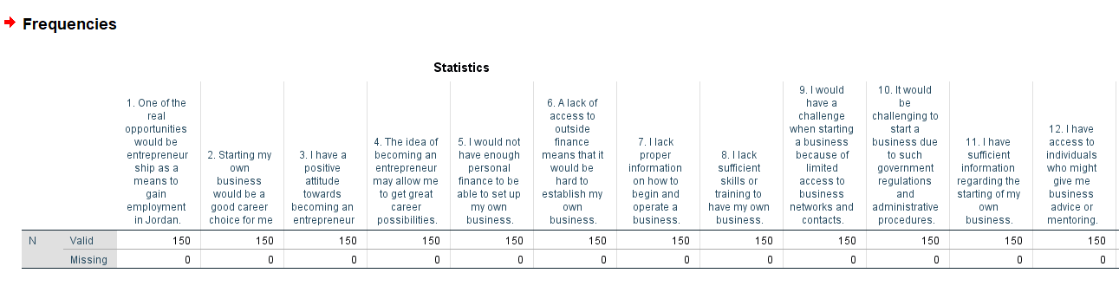
Figure 2: Frequency Statistics of Q1–Q12

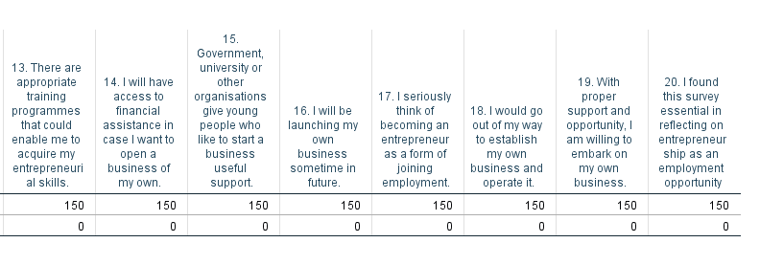
Figure 3: Frequency Statistics of Q13–Q20
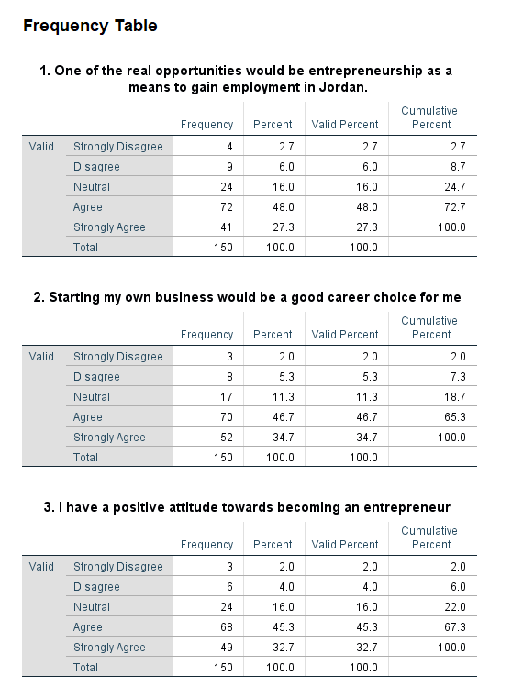
Figure 4: Frequency Tables for Q1–Q3
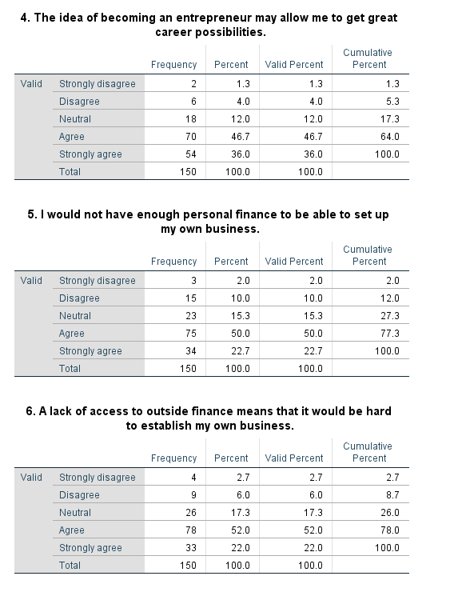
Figure 5: Frequency Tables for Q4–Q6
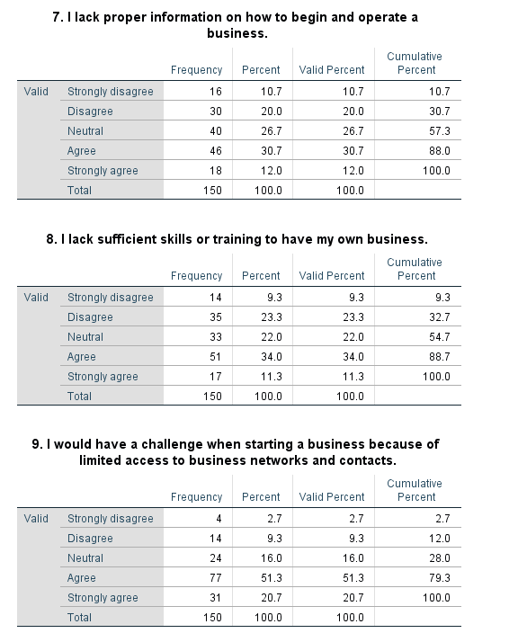
Figure 6: Frequency Tables for Q7–Q9
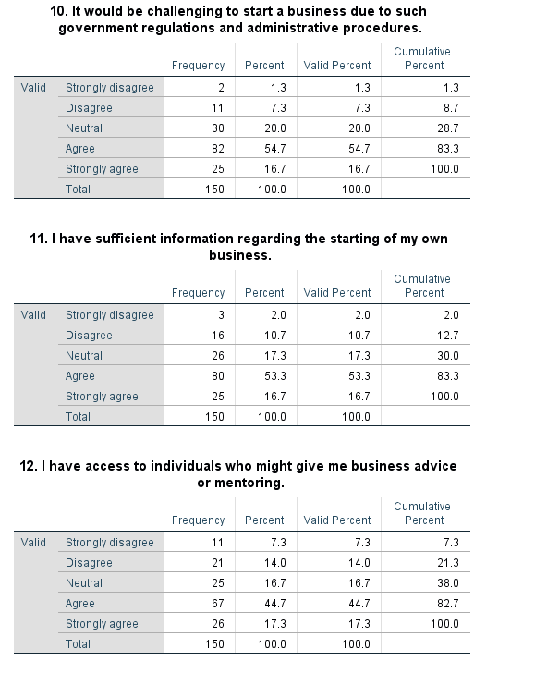
Figure 7: Frequency Tables for Q10–Q12
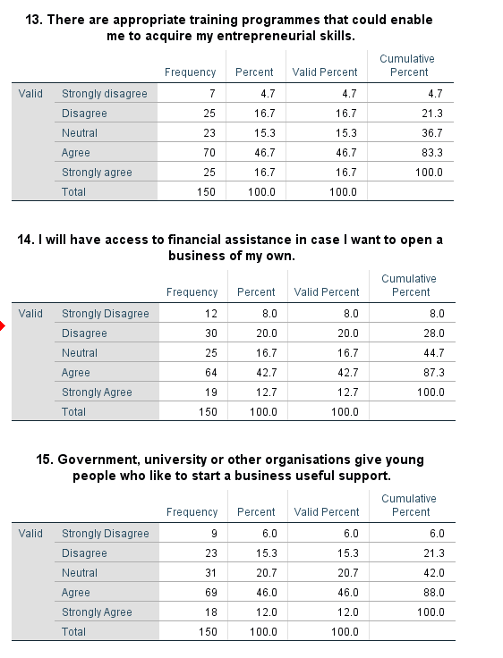
Figure 8: Frequency Tables for Q13-15
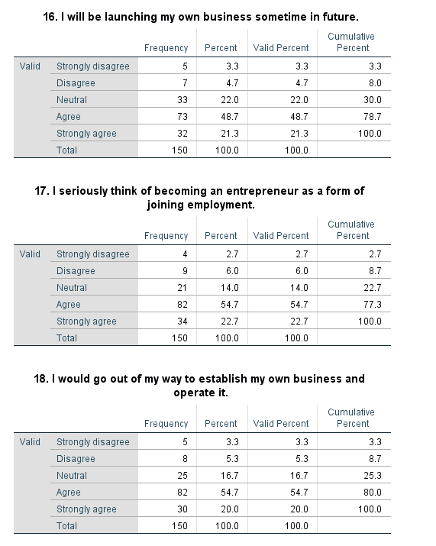
Figure 9: Frequency Tables for Q16-Q18
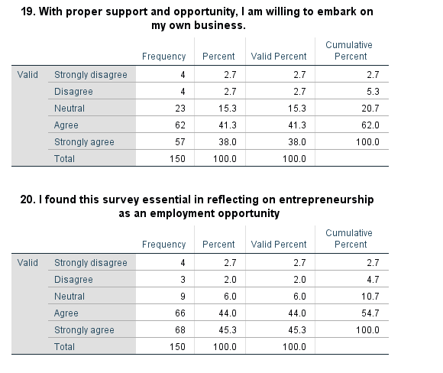
Figure 10: Frequency Tables for Q19-Q20
The frequency findings indicate that there are generally positive perceptions towards entrepreneurship. In Q1, 75.3% strongly agreed or agreed that entrepreneurship would be a source of employment, and 81.4% believed that starting a business was a good career choice (Q2). Positive attitudes were also evident in Q3 (78.0%) and Q4 (82.7%). The most notable financial barriers included: 72.7% agreed that a lack of personal finance could limit business start-up (Q5) and 74.0% that external finance is hard to access (Q6). Also, from the results, it has been identified that around 70.0% agreed with Question 16; 77.4% agreed with Q17; and the rest, 74.7% with Q18 and 79.3% with Q19.
Descriptive Statistics: Mean and Standard Deviation
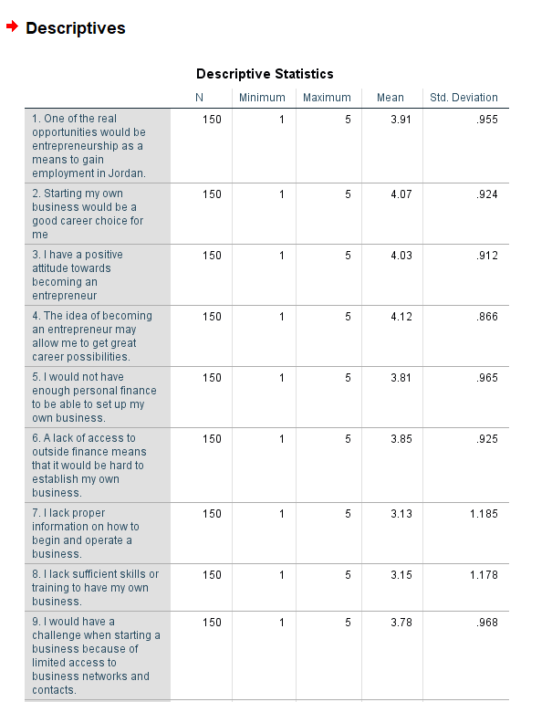
Figure 11: Descriptive Statistics Q1-Q9
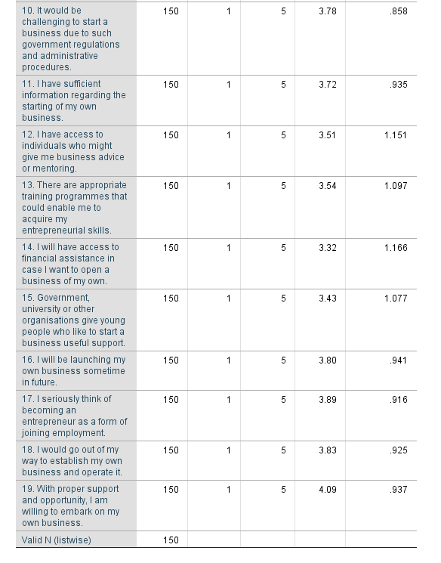
Figure 12: Descriptive Statistics Q10-Q19
From the descriptive statistics, it has been identified and analysed that there are different viewpoints in terms of entrepreneurship, with a higher score for Q4 (M = 4.12, SD = .866); this has been supported by Q19 (M = 4.09, SD = .937) and also Q2 (M = 4.07, SD = .924). Q3 also recorded a high mean (M = 4.03, SD = .912). Means of perceived barriers were lower in terms of the absence of information (Q7: M = 3.13, SD = 1.185) and the absence of skills or training (Q8: M = 3.15, SD = 1.178). Items referring to support were between M = 3.32 and M = 3.72; on the other hand, items relating to entrepreneurial intention were between M = 3.80 and M = 4.09.
Cronbach’s Alpha (Reliability Analysis)
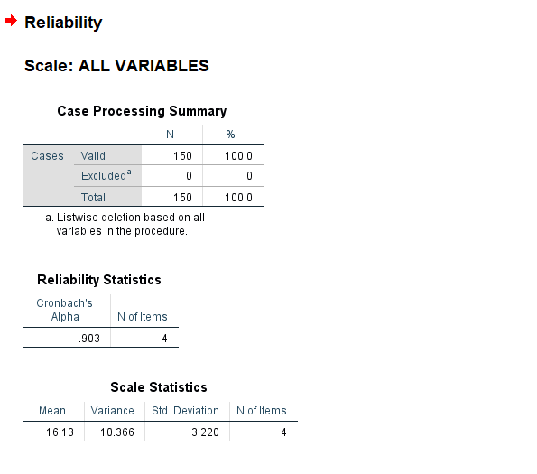
Figure 13: Reliability Analysis1-4 question
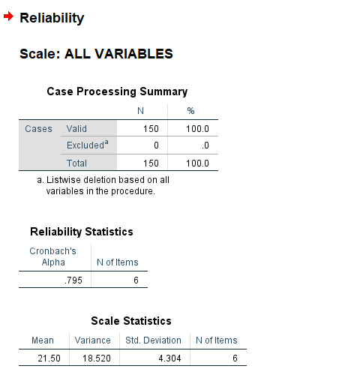
Figure 14: Reliability Analysis 5-10 question
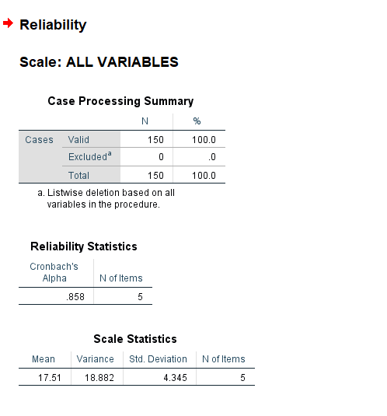
Figure 15: Reliability Analysis11-15 question
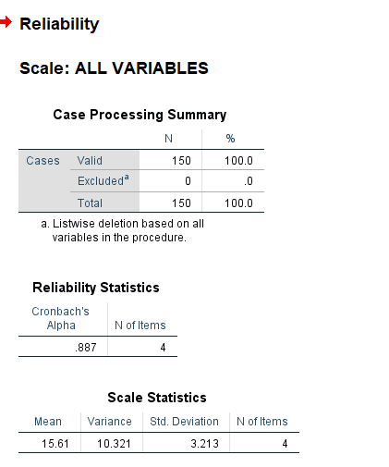
Figure 16: Reliability Analysis16-19 question
Good internal consistency was demonstrated by the reliability analysis of all four constructs. It has been noted and determined that entrepreneurial Attitude is likely to score the highest in terms of Cronbach's alpha of 0.903. In addition to this, perceived barriers are also taken into account through consideration of 6 aspects, with an alpha of about 0.795. Perceived Support measures five items and achieved a score of 0.858, and it could be stated that entrepreneurial intention is measured through 4 items with a score of 0.887. The 150 responses obtained were all valid, and no response was left out in the analysis. The findings show that there was good consistency in the items of each construct to continue with further statistical analysis. The findings justify using the four constructs in further analysis.
Correlations

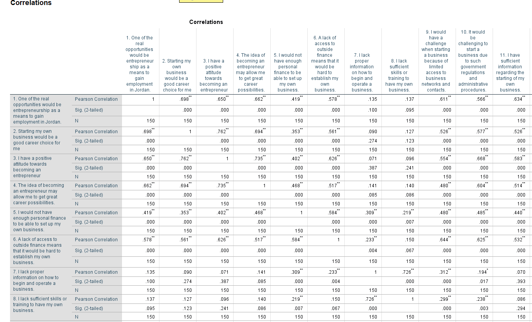
Figure 17: Pearson Correlation Results for Q1–Q11
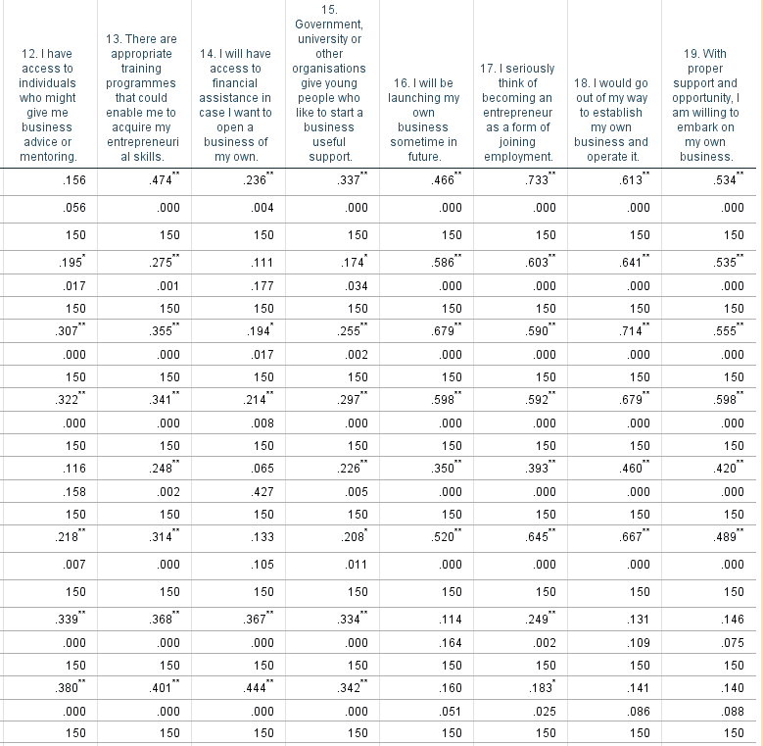
Figure 18: Pearson Correlation Results for Q12–Q19

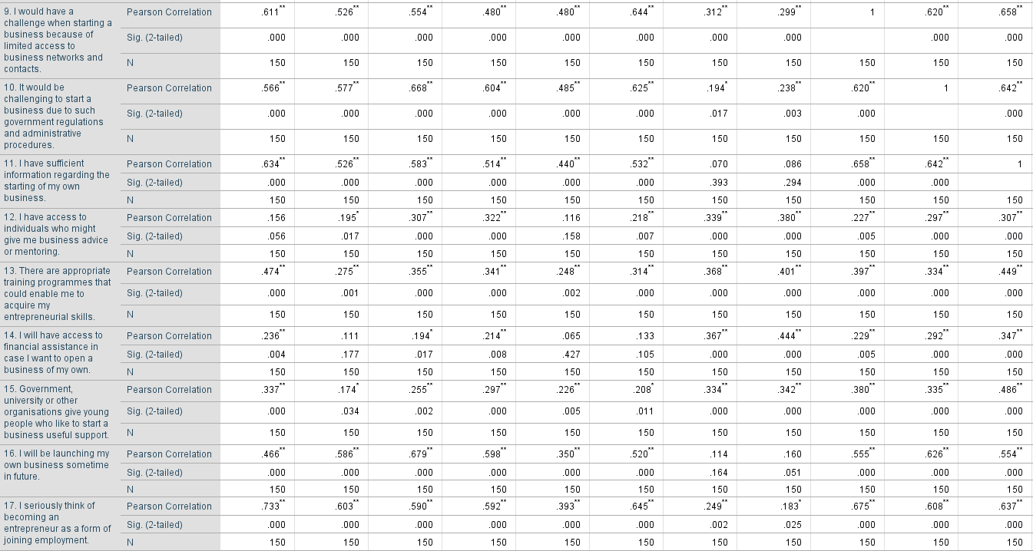
Figure 19: Pearson Correlation Results for Q9–Q17


Figure 20: Pearson Correlation Results for Q9–Q17
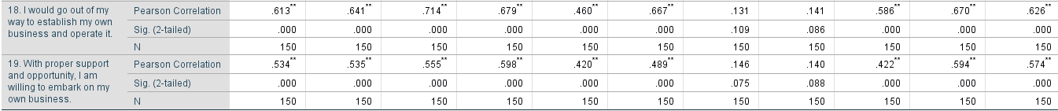
Figure 21: Pearson Correlation Results for Q18–Q19

Figure 22: Pearson Correlation Results for Q18–Q19
Results of the Pearson correlation show that most of the questionnaire variables have positive relations. From the findings it has been noted and evaluate that there is kind of correlations in terms of entrepreneurial attitude substances and also entrepreneurial intention, with inclusion of Q1 correlated with Q16 (r =.466), Q17 (r =.733), Q18 (r =.613) and Q19 (r =.534) at p =.001. Other relationships which included barriers were non-significant and weak. In general, the findings reveal that there are mainly positive relationships amongst the variables.
Multiple Linear Regression
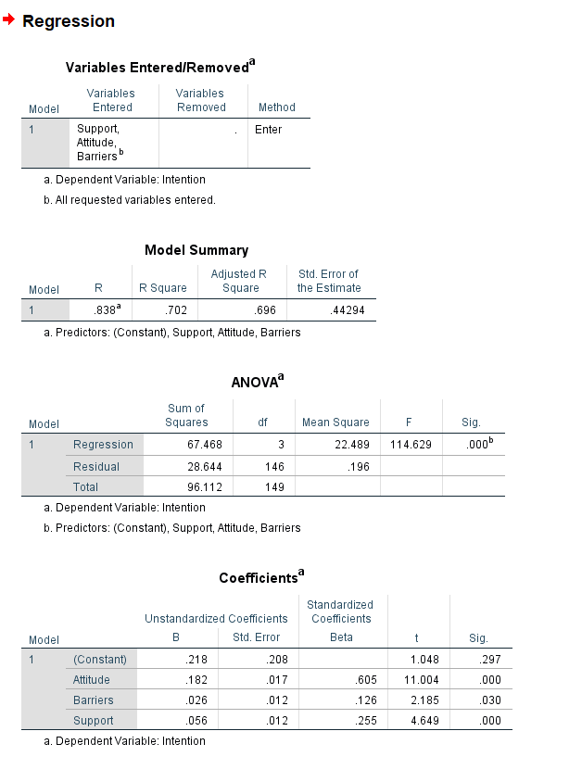
Figure 23: Multiple Linear Regression Results for Intention
From the overall findings, it has been identified and analysed that the multiple linear regression outcome reflects the different aspects, which are support, barriers, attitude and also intention. Further, the present test indicates the importance of (F = 114.629, p < .001) and this also evaluate about 70.2% of the variation in Intention (R² = .702; Adjusted R² = .696). A positive and significant relationship was also exhibited by barriers (r=.126, p =.030). Therefore, Intention was significantly contributed to by the three variables.

4.3 Analysis
Attitudes towards entrepreneurship as an employment pathway
From the findings, it has been determined that there is positive behaviour in terms of entrepreneurship among respondents. In fact, Question 1 determined that about 75.3% agreed or strongly agreed that entrepreneurship could offer jobs in Jordan. In the same manner, 81.4% concurred or strongly agreed on Q2, which regarded becoming an entrepreneur as an excellent career option. Also, Question 3 was 78.0, and Question 4 was 82.7, with a higher number of positive responses. That outcome sustained such kind of outcomes, with Question 4 recording the highest mean (M = 4.12, SD = .866), followed by Q2 (M = 4.07, SD = .924) and Q3 (M = 4.03, SD = .912). The consistency among the items of attitude was also high, with group Q1-Q4 being high, with Cronbach's alpha =0.903. The results of the correlation also indicate positive relationships among items that are related to attitude and entrepreneurial intention.
Perceived barriers to business start-up
Among respondents, financial difficulties were quite conspicuous. In Q5, 72.7% agreed or strongly agreed that a lack of personal finance would limit the start-up of a business, whereas 74.0% said that they had trouble accessing external finance in Q6. This implies that access to finance is an issue of critical concern to unemployed youth who are thinking of becoming entrepreneurs. The practical barriers outcome was, however, not as strong. Also, question 7 reflects the absence of suitable statistics to start and run a business M = 3.13, SD = 1.185, and question 8 reflects a lack of ability/skills M = 3.15, SD = 1.178. Further, the standard deviation is higher, which indicates variation in terms of respondents' viewpoints, and inter-item consistency of Perceived Barriers was good, with Cronbach's alpha = 0.795. Remarkably, there was a positive and significant correlation between Barriers and Intention in the regression analysis (β = .126, p =.030). This does not imply the existence of barriers amplifying entrepreneurial intention. Instead, it has been found that the respondent participants who perceived greater barriers also had higher Intention scores. The outcome shows that obstacles are still pertinent even in an individual who is articulating their entrepreneurial intentions.
Perceived support for entrepreneurship
The results show moderate to positive views regarding the support available. In addition to this, support-related items have mean values of M = 3.32 and M = 3.72, and this also signifies that there is no such kind of consistency among respondents. In addition to this, Cronbach's alpha attained in the reliability scrutiny of Q11-15 = 0.858, which also signifies that there is a high level of consistency in the support items. Intention was closely related to Support in the regression analysis. Support had β =.255, p =.001, which showed a positive association with Intention. This indicates that the respondents who indicated a higher perceived support also indicated a higher entrepreneurial intention.
The results also imply that support applies to youths who are thinking of becoming entrepreneurs as a source of employment. Information, advice, mentoring, training, financial support and organisational support can also be availed, thereby enabling the respondents to be more willing to think about starting a business. Nevertheless, the standard deviation of the support items shows that not all types of support were as strong among the respondents. As such, the results imply that support is still a valuable aspect of the entrepreneurial world, especially to unemployed youth who might need practical support prior to translating an intention into business practice.
Entrepreneurial intention and combined relationships
There was a good level of entrepreneurial intention in Q16-Q19 in general. Also, it has been determined that the findings indicate about 70.0% for Question 16, 77.4% for Question 17, it has been around 74.7% and for question number 18 and 19 it was about 79.3%. The regression model mainly comprises support, barriers, as well as attitude in terms of Intention. It has also been found and understood that (F = 114.629, p < .001) and evaluate in terms of 70.2% of the variation in Intention (R² = .702; Adjusted R² = .696).
Such findings mean that the entrepreneurial intention was rather high among the respondents and that the three variables that were taken into consideration in the study were applicable to the entrepreneurial intention. The findings also indicate that the sole area to which the entrepreneurial intention would be linked was not overall, as Attitude, Barriers and Support were left in the regression equation. The general model thus gives an insight into the relationship of these variables with intention among the respondents. The outcomes are especially relevant to the research question since they demonstrate that the attitudes, the perceived barriers, and the perceived support are all interlinked with the entrepreneurial intention among unemployed young Jordanians aged 18 to 35.

4.4 Discussion
Attitudes towards Entrepreneurship as an Employment Pathway
The results show that the unemployed young Jordanians tend to have favourable views on entrepreneurship as a source of employment. In the case of Q1, 75.3 per cent said they agreed or strongly agreed that entrepreneurship could be a source of jobs in Jordan, whereas 81.4 per cent believed that they made a good choice in starting a business (Q2). The presence of positive attitudes was also observed in Q3 (78.0%) and Q4 (82.7%). The mean results support this pattern, with Q4 recording the highest mean (M = 4.12, SD = .866), followed by Q2 (M = 4.07, SD = .924) and Q3 (M = 4.03, SD = .912). This means that entrepreneurship is presently taken as a positive concept by a good number of respondents and is seen as a potential pathway to jobs.
This observation is in line with those of Tian et al. (2022), who proposed that the presence of positive attitudes towards entrepreneurship is a significant predictor of entrepreneurial intention. Guo et al. (2022) also discovered that positive entrepreneurial attitudes are relevant in influencing intentions to establish a business. The current results thus substantiate the perspective that positive attitudes towards entrepreneurship apply to unemployed youth in view of alternative job opportunities.
From the above findings and analysis, it has been determined that the overall outcome was mainly supported through consideration of the reliability test, as 4 different items were taken into account that reflect the consistency between question 1 and question 4. Along with this, the analysis through regression also indicates a higher correlation with the inclusion of intention (β =.605, p =.001). It could be stated that this is a stronger connection than that pointed out in terms of barriers (β = .126, p = .030), which is also supported (β = .255, p < .001). It thus follows that the outcome is highly congruent with Tian et al. (2022) and Guo et al. (2022), since the positive attitude of the respondents is also corroborated by the high correlation between Attitude and Intention.
Nonetheless, the result contrasts with the more conservative stance of Alkhozahe (2025), who believed that positive attitudes of unemployed young Jordanians do not lead them to start businesses since economic uncertainty and insecurity in the labour market can decrease confidence. The current research does not determine that the respondents in fact started businesses; it is an Intention. Thus, the results favour the contention that entrepreneurship is considered a viable source of employment, yet they do not prove the existence of positive attitudes that lead to the establishment of a business. This difference also aligns with Kovaleva et al. (2023), who have uncovered that an individual may consider entrepreneurship as a good career choice without always having intentions to go into business.
Perceived Barriers to Starting a Business
The results indicate that the economic and practical issues are a significant source of concern among the unemployed youth. In Q5, 72.7 also believed or strongly believed that a lack of personal finance might limit their capacity to start a business, and 74.0% stated that they found it hard to access external finance in Q6. The mean for Q5 was M = 3.81, SD = .965, while Q6 recorded M = 3.85, SD = .925. These findings show that access to finance is among the more pronounced challenges that the respondents experience with regard to business creation.
This observation concurs with Belhaj Fraj et al. (2022), who cited funding issues, collateral and inaccessibility of banking funds as limitations to young entrepreneurs in Jordan. It also agrees with Bozward et al. (2022), who opined that inadequate start-up capital limits entrepreneurship. Those findings thus point to the presence of positive attitudes towards entrepreneurship as well as questions regarding whether the respondents have enough financial resources to pursue these positive attitudes.
Additional barriers were found as well, but at low means. Q7, related to information on how to start and run a business, had M = 3.13, SD = 1.185 and Q8, related to having sufficient skills or training, had M = 3.15, SD = 1.178. Q9 and Q10 were also related to business networks and government regulations. These findings imply that the barriers are not just restricted to finance, but rather, one can find them in knowledge, skills, networks and administrative needs. This confirms the fact that Auerbach and Green (2025) argued that education and entrepreneurial skills can enhance the ability of individuals, whilst also indicating that Edeji (24) said education might not deal with offering enough hands-on entrepreneurial training.
The results are also comparable to those of Kromidha et al. (2022), who established broader social and institutional challenges influencing entrepreneurial decision-making of young people. Nonetheless, the outcome of the regression suggests a significant variation from the assumption that intention should be decreased by barriers as a matter of necessity. There was a positive and significant correlation between Barriers and Intention (r =.126, p =.030). This does not imply that the barriers aggravate entrepreneurial intention. Instead, there were higher scores related to Intention reported by the respondents, indicating higher perceived barriers. This can mean that the youth are aware of the hardships that come with entrepreneurship but are not considering it as a job opportunity.
Perceived Support and Entrepreneurial Intention
The results indicate that the respondents moderately positively perceived the assistance they had. Items on support were between M = 3.32 and M = 3.72. Q11, with regard to the information about beginning a business, had M = 3.72, SD =.935 and Q12, with regard to accessing business advice or mentoring, had M = 3.51, SD = 0.152. Q13 recorded M = 3.54, SD = 1.097, Q14 recorded M = 3.32, SD = 1.166, and Q15 recorded M = 3.43, SD = 1.077. Therefore, there was support, but it was not equally high within the sphere of financial assistance, training, mentoring and organisational support.
This observation aligns with the results of Mawson, Casulli and Simmons (2023), who concluded that entrepreneurship education had the potential to enhance confidence using business-based knowledge, opportunity identification and decision-making abilities. Similar findings reported by Daspit, Fox and Findley (2023) indicated that entrepreneurial education has the potential to ensure entrepreneurial intention, especially when learning is practised. The existing evidence supports the latter arguments partially in that the respondents indicated access to information and training, even though the results do not indicate similar positive perceptions of all types of support.
The regression outcome provides better evidence on the relationship between support and intention. Intention was positively and significantly correlated with Support (2 =.255, p <.001). This helps substantiate the viewpoint of Kayed, Al-Madadha and Basal (2022) that assistance can boost entrepreneurial action through the decrease of constraints among every potential entrepreneur. It also concurs with Clayton (2024), who stressed the relevance of using a mix of finance with mentoring and technical support instead of using solely financial assistance.
However, the results also show the apprehensions as expressed by Martínez-Gregorio and Oliver (2024) and Cativiela (2023). Although there was a significant correlation between Support and Intention, the coefficient (=.255) of Support was less than that of Attitude (=.605). This indicates that support is not irrelevant, and the positive views of entrepreneurship correlate more with Intention in this sample. Consequently, support programmes might not be enough to deal with youth unemployment.
Entrepreneurial Intention and the Combined Influence of Attitude, Barriers and Support
The level of entrepreneurial intention was fairly high among the respondents. The overall outcome indicates about 70.0% agreement with Q16, and the rest 77.4% with Question 17, 74.7% with Q18 and 79.3% with Q19. The means for the intention items ranged from M = 3.80 to M = 4.09, with Q19 recording the highest mean (M = 4.09, SD = .937). Internal consistency was also good based on the four intention items, with Cronbach’s alpha = 0.887.
These findings of correlation lend more support to the positive associations between attitudes and intention. Question 1 is mainly deliberate in that it has been correlated with Question 16 (r = .466), Question 17 (r = .733), as well as Question 18 (r = .613) and Q19 (r = .534), all at p < .001. Also, the intention items were strongly related to one another, including Q16–Q18 (r = .679), Q17–Q18 (r = .708) and Q18–Q19 (r = .693), all p < .001. These results are generally in line with the results given by Tian et al. (2022), Guo et al. (2022) and the Theory of Planned Behaviour as described in the Literature Review.
The multiple regression gives the most lucrative overall result. It has been noted and determined that support, barriers and attitude were fundamental, as this has been valued around (F = 114.629, p < .001); also, this has accounted for 70.2% of the variation in relation to Intention (R2=.702; Adjusted R2=.696). Further, it could be stated that attitude is considered the strongest connection with Intention (β = .605, p < .001), followed by the aspect of Support (β = .255, p < .001) and Barriers (β = .126, p = .030).
This partially substantiates the literature since Tian et al. (2022) and Guo et al. (2022) prioritise attitudes, whereas Mawson et al. (2023), Daspit et al. (2023) and Kayed et al. (2022) prioritise support. Simultaneously, the outcomes indicate that the argument by Rodrik and Stiglitz (2025) claiming that entrepreneurship ought not to substitute for formal employment but to be its complement holds true, especially in cases where the institutional circumstances are still relevant. In general, the results demonstrate that entrepreneurship may be discussed as a successful employment option for the respondents, yet the positive attitudes, perceived obstacles and potential assistance are still topical to the intention of the unemployed youth to choose it.

4.5 Chapter summary
In this chapter, the authors outlined and discussed the results of 150 valid answers from unemployed Jordanians aged 18 to 35. The findings revealed that there were generally positive attitudes towards entrepreneurship, with a high agreement with Q1-Q4. Barriers to finance were found to be critical, such as a lack of personal finance and external finance. Perceived support was moderate in terms of information, mentoring, training, financial assistance and organisational support. Entrepreneurial intention was also fairly high in Q16-Q19. Results on reliability guaranteed consistency in the four constructs. The result of Pearson correlation revealed that there were positive correlations between most of the questionnaire variables. The model of the multiple regression was significant (F = 114.629, p = -.001) and explained Intention variation 70.2 (R 2 =.702; Adjusted R 2 =.696). Attitude was most related to Intention, along with Support and Barriers.

Chapter 5: Conclusion

5.1 Conclusion
This paper has discussed the possibility of entrepreneurship being an option for entry into employment among unemployed Jordanians within the age group of 18- 35 years. The results indicate the positive attitude of a significant percentage of participants towards entrepreneurship and the possibility of it serving as an alternative source of employment. Nevertheless, the findings also indicate that positive attitudes alone cannot render entrepreneurship a feasible option. The issues of financial problems, access to external funds, business knowledge and skills, networks and administrative needs still pose a significant issue. The results indicated that three-quarters (75.3%) of the participants strongly agreed or agreed that entrepreneurship would create jobs in Jordan, and three-quarters (81.4%) of respondents believed that a good career choice could be starting a business. Entrepreneurial intention was also quite high, especially when the respondents indicated that they would have been willing to start a business with appropriate support. Meanwhile, 72.7% saw a lack of personal finance as an obstacle, and 74.0% had trouble accessing external finance. The statistical analysis also revealed that entrepreneurial intention was related to attitudes, perceived support and perceived barriers. The regression model attributed 70.2% of the variance in intention, and the strongest association was with attitude, followed by support and barriers. Consequently, entrepreneurship may be viewed as a viable employment option for a certain segment of unemployed young Jordanians, yet it should not be seen as a total substitute for an official job. Its success hinges on the possibility of young people having the means to transform the intention into a real business.

5.2 Recommendations
- Policymakers need to enhance access to cheap start-up funds among unemployed youth. Clear instructions on applications, business planning and financial management should be provided to fund the organisation effectively through financial aid. This is especially crucial as one of the greatest obstacles identified by the respondents was that of finance (Audretsch, and Fiedler 2023).
- Universities need to embrace more applied and practical entrepreneurship training instead of theoretical learning. It should be focused on business planning, budgeting, marketing, market research and practical business activities. This would assist the youth to build more confidence, as well as knowledge, prior to starting a business.
- Mentoring, business advice and networking should be enhanced by support organisations. Youths ought to be in a position to get advice from skilled business proprietors, and they should get advice on information regarding available programmes. Support that is already in place must also be more readily available/handy (Auerbach, and Green 2025).
- Finally, the work of entrepreneurship programmes should be coordinated with the broader youth policies on employment. Entrepreneurship is to offer another source of employment opportunity and not to stand out as the ultimate remedy to unemployment.

5.3 Summary of research contribution and its alignment with research objectives
The study adds to a better understanding of the way unemployed Jordanians between the ages of 18 and 35 consider entrepreneurship as a job prospect. It incorporates attitudinal, perceived barriers, perceived support and entrepreneurial intention, and does not look at these aspects individually. The initial goal was reached when positive attitudes towards entrepreneurship were found in general. The second aim was met by identifying financial, practical, knowledge, skills, network and administrative obstacles. The third objective was achieved through the analysis of the relationship that existed between the perception of support and entrepreneurial intention, with support having a positive correlation with intention. The fourth aim was fulfilled using primary survey data from 150 unemployed Jordanians aged between 18 and 35. Lastly, the findings provide grounds for recommendations to influence policymakers, universities, and support organisations.

5.4 Limitations and future directions
There are limitations of the study. The purposive and voluntary snowball sampling implies that the respondents will not necessarily represent all unemployed young Jordanians. In the research itself, it is acknowledged that such a method of sampling cannot ensure the representation of the broader population. The type of study was also a cross-sectional study, since the data gathered were at a single point in time.
Moreover, only the entrepreneurial intention was measured, but not the establishment of a business by the respondents. The study might be further refined by an increased, more representative sample and by making the study participants based in various regions of Jordan. Another method to apply longitudinal research would be to trace the young people over a period to see whether their entrepreneurial intention leads to the performance of business and continuing to do business.

5.5 Personal reflection and development
The completion of this research enhanced my knowledge of the process of a research project, such as identification of the problem, collection and analysis of primary data. I gained more confidence in designing a questionnaire, engaging the respondents and statistical analysis outcomes. Another learning outcome that I received was the need to relate research objectives with research questions asked and analysis conducted.
The study enhanced my skills in outlining significant findings as opposed to reporting numbers. The other things I gained are a clearer understanding of what being an unemployed youth with entrepreneurial thoughts entails. Comprehensively, the project improved my writing abilities, academic and analytical, in addition to offering the opportunity to gain valuable experience which I can use in my future academic and professional undertakings.

References
Al-Ali, A.H. (2022) An empirical investigation of the determinants of entrepreneurial intention among public and private university students in Jordan. Journal of Positive School Psychology, 6(6). https://journalppw.com/index.php/jpsp/article/view/8646
Alharbi, M. M. H. (2020) Entrepreneurship and job creation in Jordan: challenges and prospects for start-ups. Journal La Bisecoman, 1(3), 1-10. https://doi.org/10.37899/journallabisecoman.v1i3.114
Alkhozahe, H. O. (2025) Causes of Unemployment in Jordan and Solutions from the Point of View of Unemployed Youth. Dirasat: Human & Social Sciences, 52. https://doi.org/10.35516/hum.v52i6.8042
Alshraiedeh, B. (2024) Unemployment in Jordan: Causes and Possible Solutions. https://theses.cz/id/bzvpf9/Abstract_Diploma_Thesis_AlShraiedeh_final_Archive.pdf
Amofah, K. and Saladrigues, R. (2022) Impact of attitude towards entrepreneurship education and role models on entrepreneurial intention. Journal of Innovation and Entrepreneurship, 11, 36. https://doi.org/10.1186/s13731-022-00197-5
Anjum, T., Amoozegar, A., Farrukh, M., and Heidler, P. (2023) Entrepreneurial intentions among business students: the mediating role of attitude and the moderating role of university support. Education+ Training, 65(4), 587-606. https://doi.org/10.1108/ET-01-2021-0020
Audretsch, D.B. and Fiedler, A. (2023) Power and entrepreneurship. Small Business Economics, 60(4), pp.1573-1592. https://doi.org/10.1007/s11187-022-00660-3
Auerbach, P. and Green, F. (2025) Reformulating the critique of human capital theory. Journal of Economic Surveys, 39(5), pp.1839-1851. https://doi.org/10.1111/joes.12675
Bamdad, S., Finaughty, D. A., and Johns, S. E. (2022) ‘Grey areas’: ethical challenges posed by social media-enabled recruitment and online data collection in cross-border, social science research. Research Ethics, 18(1), 24-38. https://doi.org/10.1177/17470161211045557
Banka, M., Chmiel, N., Kostrzewski, M., Marczewska, M., Kowalski, A. M., Sedkiewicz, K., and Salwin, M. (2024) Understanding corporate concerns. Barriers and challenges in corporate–start-up collaboration. Journal of Open Innovation: Technology, Market, and Complexity, 10(4), 100388. https://doi.org/10.1016/j.joitmc.2024.100388
Belhaj Fraj, M., Al-Dabbas, L., Al-Zyoud, O., Abu Keshek, A., Fragaszy, S., Ruckstuhl, S., and McDonnell, R. (2022) Initial drought risk finance market assessment for Jordan. https://cgspace.cgiar.org/items/d2c59a40-f489-4861-8368-1cb79323fe4b
Bishop, D. V. (2026) A Delphi survey on attitudes to serious research misconduct: Exploring convergence vs. polarisation of views of research "sleuths" and research integrity experts. Accountability in Research, 2632079. https://doi.org/10.1080/08989621.2026.2632079
Botelho, T.L., Fehder, D.C. and Hochberg, Y.V. (2026) Innovation-driven entrepreneurship. Journal of Economic Literature, 64(1), pp.89-140. https://www.nber.org/system/files/working_papers/w28990/w28990.pdf
Bozward, D., Rogers-Draycott, M., Angba, C. and Zhang, C. (2022) How can entrepreneurial interventions in a university context impact the entrepreneurial intention of their students? Entrepreneurship Education, 6(1), pp.1–23. https://doi.org/10.1007/s41959-022-00083-x
Cativiela, P. (2023) Building a Society of Trust: Innovation and the Future of Youth Employment in Jordan. https://digitalcollections.sit.edu/isp_collection/3597/
Clayton, P. (2024) Different outcomes for different founders? Local organizational sponsorship and entrepreneurial finance. Small business economics, 62(1), 23-62. https://doi.org/10.1007/s11187-023-00753-7
Creswell, J. W., and Inoue, M. (2025) A process for conducting mixed methods data analysis. Journal of General and Family Medicine, 26(1), 4-11. https://doi.org/10.1002/jgf2.736
Daspit, J.J., Fox, C.J. and Findley, S.K. (2023) Entrepreneurial mindset: An integrated definition, a review of current insights, and directions for future research. Journal of Small Business Management, 61(1), pp.12-44. https://doi.org/10.1080/00472778.2021.1907583
Decker-Lange, C., Lange, K., and Walmsley, A. (2024) How does entrepreneurship education affect employability? Insights from UK higher education. International Journal of Entrepreneurial Behavior & Research, 30(5), 1249-1269. https://doi.org/10.1108/IJEBR-08-2023-0856
Devictor, J., Burnet, E., Henriot, T., Leclercq, A., Ganne‐Carrie, N., Kilpatrick, K., and Jovic, L. (2023) Implementing advanced practice nursing in France: A country‐wide survey 2 years after its introduction. Nursing open, 10(3), 1437-1448. https://doi.org/10.1002/nop2.1394
Dieguez, T., and Gomes, S. (2025) Bridging intention and action in sustainable university entrepreneurship: The role of motivation and institutional support. Administrative Sciences, 15(11), 422. https://doi.org/10.3390/admsci15110422
Edeji, O.C. (2024) Neo-liberalism, human capital theory and the right to education: Economic interpretation of the purpose of education. Social Sciences & Humanities Open, 9, p.100734. https://doi.org/10.1016/j.ssaho.2023.100734
Grugulis, I. (2024) Human capital theory. In A guide to key theories for human resource management research (pp. 93-99). Edward Elgar Publishing. https://doi.org/10.4337/9781035308767.ch10
Guo, J., Cheng, Z. and Wang, B.Z. (2024) Internet development and entrepreneurship. China Economic Review, 88, p.102280. https://doi.org/10.1016/j.chieco.2024.102280
Guo, X., Edghiem, F., Dakhan, S.A. and Khan, M. (2022) Investigating female students’ entrepreneurial intention in the UK and Pakistan: An application of TPB. In Entrepreneurship and Change: Understanding Entrepreneurialism as a Driver of Transformation. Palgrave Macmillan. https://doi.org/10.1007/978-3-031-07139-3_6
Huang, Y., Li, P., Chen, L. and Wang, J. (2023) Opportunity or necessity entrepreneurship? A study based on the national system of entrepreneurship. Journal of Innovation & Knowledge, 8(4), p.100448. https://doi.org/10.1016/j.jik.2023.100448
Jannesari, M.T. (2022) Predictors of International Entrepreneurial Intention Among Young Adults: Social Cognitive Theory. Frontiers in Psychology, 13, 894717. https://doi.org/10.3389/fpsyg.2022.894717
Kayed, H., Al-Madadha, A. and Basal, A.M. (2022) The Effect of Entrepreneurial Education and Culture on Entrepreneurial Intention. Organizacija, 55(1), pp.18–34. https://doi.org/10.2478/orga-2022-0002
Kovaleva, Y., Hyrynsalmi, S., Saltan, A., Happonen, A., and Kasurinen, J. (2023) Becoming an entrepreneur: A study of factors with women from the tech sector. Information and Software Technology, 155, 107110. https://doi.org/10.1016/j.infsof.2022.107110
Kromidha, E., Altinay, L., Madanoglu, G.K., Nurmagambetova, A. and Madanoglu, M. (2022) Cultural intelligence, entrepreneurial intentions and the moderating role of the institutional environment. International Journal of Entrepreneurial Behavior & Research, 28(6), pp.1581–1608. https://doi.org/10.1108/IJEBR-02-2022-0109
Lachheb, A., Abramenka‐Lachheb, V., Moore, S., and Gray, C. (2023) The role of design ethics in maintaining students' privacy: A call to action to learning designers in higher education. British Journal of Educational Technology, 54(6), 1653-1670. https://doi.org/10.1111/bjet.13382
Maheshwari, G., Kha, K.L. and Arokiasamy, L. (2023) Factors affecting students' entrepreneurial intentions: A systematic review. Management Review Quarterly, 73, pp.1903–1970. https://doi.org/10.1007/s11301-022-00289-2
Makai, A. L., and Dőry, T. (2023) Perceived university support and environment as a factor of entrepreneurial intention: Evidence from Western Transdanubia Region. Plos one, 18(6), e0283850. https://doi.org/10.1371/journal.pone.0283850
Martínez-Gregorio, S. and Oliver, A. (2022) Measuring entrepreneurship intention in secondary education: Validation of the Entrepreneurial Intention Questionnaire. Journal of Psychoeducational Assessment, 40(4), pp.499–513. https://doi.org/10.1177/07342829211069222
Mawson, S., Casulli, L. and Simmons, E.L. (2023) A competence development approach for entrepreneurial mindset in entrepreneurship education. Entrepreneurship Education and Pedagogy, 6(3), pp.481-501. https://doi.org/10.1177/25151274221143146
Moreira, S., Mamede, H. S., and Santos, A. (2024) Business process automation in SMEs: a systematic literature review. IEEE access, 12, 75832-75864. https://doi.org/10.1109/ACCESS.2024.3406548
Morrar, R., Yerousis, G., and O'Carroll, C. (2025) Navigating Pathways in Entrepreneurship: A Comparative Study of the Challenges and Opportunities in Palestine, Jordan, and Egypt. An-Najah University Journal for Research-B (Humanities), 39(12), 1109-1130. https://doi.org/10.35552/0247.39.12.2482
Nabi, G., Liñán, F., Fayolle, A., Krueger, N. and Walmsley, A. (2023) The impact of entrepreneurship education in higher education: A systematic review and research agenda. Academy of Management Learning & Education, 22(2), pp.167–192. https://doi.org/10.5465/amle.2020.0376
Nate, S., Grecu, V., Stavytskyy, A., and Kharlamova, G. (2022) Fostering entrepreneurial ecosystems through the stimulation and mentorship of new entrepreneurs. Sustainability, 14(13), 7985. https://doi.org/10.3390/su14137985
Obschonka, M., Moeller, J. and Goethner, M. (2022) Entrepreneurial passion and personality: The case for a personality systems approach. Journal of Business Research, 145, pp.860–872. https://doi.org/10.1016/j.jbusres.2022.03.005
Pellert, M., Lechner, C. M., Wagner, C., Rammstedt, B., and Strohmaier, M. (2024) Ai psychometrics: Assessing the psychological profiles of large language models through psychometric inventories. Perspectives on Psychological Science, 19(5), 808-826. https://doi.org/10.1177/17456916231214460
Randall, T., Cousins, A. L., Neilson, L., Price, M., Hardman, C. A., and Wilkinson, L. L. (2024) Sustainable food consumption across Western and Non-Western cultures: A scoping review considering the theory of planned behaviour. Food Quality and Preference, 114, 105086. https://doi.org/10.1016/j.foodqual.2023.105086
Ratten, V. (2023) Entrepreneurship: Definitions, opportunities, challenges, and future directions. Global Business and Organizational Excellence, 42(5), pp.79-90. DOI: 10.1002/joe.22217
Rodrik, D., and Stiglitz, J. E. (2025) A new growth strategy for developing nations. In The New Global Economic Order (pp. 89-107). Routledge. https://www.taylorfrancis.com/chapters/oa-edit/10.4324/9781003571384-7/new-growth-strategy-developing-nations-dani-rodrik-joseph-stiglitz
Rodrik, D., and Stiglitz, J. E. (2025) A new growth strategy for developing nations. In The New Global Economic Order (pp. 89-107). Routledge. https://www.taylorfrancis.com/chapters/oa-edit/10.4324/9781003571384-7/new-growth-strategy-developing-nations-dani-rodrik-joseph-stiglitz
Shahriar, M. S., Hassan, M. S., Islam, M. A., Sobhani, F. A., and Islam, M. T. (2024) Entrepreneurial intention among university students of a developing economy: the mediating role of access to finance and entrepreneurship program. Cogent Business & Management, 11(1), 2322021. https://doi.org/10.1080/23311975.2024.2322021
Tian, H., Akhtar, S., Qureshi, N.A. and Iqbal, S. (2022) Predictors of entrepreneurial intentions: The role of prior business experience, opportunity recognition, and entrepreneurial education. Frontiers in Psychology, 13, 882159. https://doi.org/10.3389/fpsyg.2022.882159
Wang, Z. and Ortiz, G.G.R. (2022) Assessing the management student's entrepreneurial intentions: Role of entrepreneurship education and technology transfer. Frontiers in Psychology, 13, 953324. https://doi.org/10.3389/fpsyg.2022.953324
Welsh, D.H.B., Othman, D., Alserhan, B., Zeqiri, J. and Al-Madadha, A. (2022) The impact of the international crisis on the entrepreneurial intentions of refugees. International Journal of Entrepreneurial Behavior & Research, 28(3), pp.720–740. https://doi.org/10.1108/IJEBR-02-2021-0150

Appendix

Questionnaire
1. One of the real opportunities would be entrepreneurship as a means to gain employment in Jordan.
- Strongly Disagree
- Disagree
- Neutral
- Agree
- Strongly Agree
2. Starting my own business would be a good career choice for me
- Strongly Disagree
- Disagree
- Neutral
- Agree
- Strongly Agree
3. I have a positive attitude towards becoming an entrepreneur
- Strongly Disagree
- Disagree
- Neutral
- Agree
- Strongly Agree
4. The idea of becoming an entrepreneur may allow me to get great career possibilities.
- Strongly Disagree
- Disagree
- Neutral
- Agree
- Strongly Agree
5. I would not have enough personal finance to be able to set up my own business.
- Strongly Disagree
- Disagree
- Neutral
- Agree
- Strongly Agree
6. A lack of access to outside finance means that it would be hard to establish my own business.
- Strongly Disagree
- Disagree
- Neutral
- Agree
- Strongly Agree
7. I lack proper information on how to begin and operate a business.
- Strongly Disagree
- Disagree
- Neutral
- Agree
- Strongly Agree
8. I lack sufficient skills or training to have my own business.
- Strongly Disagree
- Disagree
- Neutral
- Agree
- Strongly Agree
9. I would have a challenge when starting a business because of limited access to business networks and contacts.
- Strongly Disagree
- Disagree
- Neutral
- Agree
- Strongly Agree
10. It would be challenging to start a business due to such government regulations and administrative procedures.
- Strongly Disagree
- Disagree
- Neutral
- Agree
- Strongly Agree
11. I have sufficient information regarding the starting of my own business.
- Strongly Disagree
- Disagree
- Neutral
- Agree
- Strongly Agree
12. I have access to individuals who might give me business advice or mentoring.
- Strongly Disagree
- Disagree
- Neutral
- Agree
- Strongly Agree
13. There are appropriate training programmes that could enable me to acquire my entrepreneurial skills.
- Strongly Disagree
- Disagree
- Neutral
- Agree
- Strongly Agree
14. I will have access to financial assistance in case I want to open a business of my own.
- Strongly Disagree
- Disagree
- Neutral
- Agree
- Strongly Agree
15. Government, university or other organisations give young people who like to start a business useful support.
- Strongly Disagree
- Disagree
- Neutral
- Agree
- Strongly Agree
16. I will be launching my own business sometime in future.
- Strongly Disagree
- Disagree
- Neutral
- Agree
- Strongly Agree
17. I seriously think of becoming an entrepreneur as a form of joining employment.
- Strongly Disagree
- Disagree
- Neutral
- Agree
- Strongly Agree
18. I would go out of my way to establish my own business and operate it.
- Strongly Disagree
- Disagree
- Neutral
- Agree
- Strongly Agree
19. With proper support and opportunity, I am willing to embark on my own business.
- Strongly Disagree
- Disagree
- Neutral
- Agree
- Strongly Agree
20. I found this survey essential in reflecting on entrepreneurship as an employment opportunity
- Strongly Disagree
- Disagree
- Neutral
- Agree
- Strongly Agree

Google link
https://docs.google.com/forms/d/1jvmQqNoQAEgJAiZ0Vc18i98Pfgzlq9CWXtYd1Yx34VY/edit?pli=1

